Wyoming Transcript Center: Archives

About the Transcript Archive
The Transcript Archive is a permanent repository for students’ last transcripts. A "last" transcript is the latest transcript for a student at a particular institution. (WTC stores only one transcript per combination of student ID and institution.) The "last" transcript could be:
- the student’s final transcript after graduating from high school;
- the student’s final transcript before leaving a particular institution;
- a transcript reflecting the most recent coursework, grades, and credits for a currently enrolled student who is continuing toward graduation.
The Transcript Archive is stored independently from uploaded and received transcripts, but is accessible through the WTC interface by authorized campus-, district-, region- and state-level users.
Note: At present, the Transcript Archive stores transcripts for only middle and high schools; it does not yet support elementary, post-secondary or co-academic institutions.
Authorized users can:
- Add transcripts to the Transcript Archive
  - Directly—by selecting the Archive command on the Manage Uploaded Records/Transcripts page of the WTC user interface;
  - Automatically—when the retention period for uploaded transcripts has passed. (The retention period is set in the Partner account, in the purge policy settings which can be the default retention period of 60 days, or a user-defined retention period of up to a maximum of 270 days.)
  - Upon Confirming Deletion—when user selects the option to archive deleted records/transcripts by confirming the "Archive selected records/transcripts" option in the deletion confirmation dialog.
- View or search the Transcript Archive.
  - Directly—through the View Archived Transcripts page of the WTC interface;
  - In fulfillment of a transcript order from a former student, through OrderATranscript.com— as the order is matched against archived transcripts.

Sending a Record/Transcript to the Transcript Archive
Through the WTC interface, you can directly archive transcripts of former students, transcripts of students who have left the institution, or the latest transcripts of a currently enrolled student.
To add transcripts to the archive:
- Log into WTC.
- From the WTC home page, click on the Manage uploaded records/transcripts link.
- The Manage Uploaded Records/Transcripts page displays a list of transcripts for your institution.
- Select one or more transcripts to archive.
- Selection of records/transcripts activates the buttons at the bottom of the page: Delete, Upload, Archive, Download, and Download PDF.
- To archive selected records/transcripts, click on the Archive button.
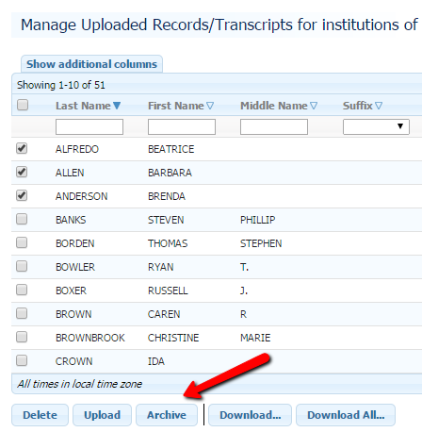
Note: Attachments (such as art portfolios, photographs, etc.) are not stored in the Transcript Archive; these documents are not saved when a record is archived.
- The selected transcripts are added to the Transcript Archive; the Manage Uploaded Records/Transcripts page is updated to display an icon beside the transcripts that have been archived. (This process is not immediate; it will take some time before the archived record appears in "View Archived Records".)
The “piece of paper” icon indicates that a transcript has been archived.
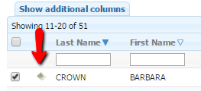
- Click Done to return to the home page.

Viewing Archived Transcripts
You can view or search the Transcript Archive for your institution through the View archived transcripts link on the WTC home page if you have the appropriate permissions.
To view archived transcripts:
- Log in to WTC.
- From the WTC home page, select the View Archived Transcripts link.
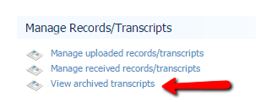
The View archived transcripts (for your institution) page is displayed.
- Select the archived transcript you wish to view.
Choose an archived transcript directly from the displayed list; or
Filter the list by enabling the Search fields: Enter matching data (Name, Gender, Date of Birth, etc.), and press Enter to filter the list for the archived transcript you wish to view.
- In the View column, select the PDF link for the archived transcript you wish to view.
A PDF object for the archived transcript is displayed. (Note the "Archived" watermark that appears on the page, distinguishing this transcript from other uploaded or received transcripts or records.)
- Close the PDF object; the interface is still open at the View Archived Transcripts page.
- Click Done to return to the home page.

Sending Deleted Transcripts to the Archive
When you select records/transcripts for deletion, you can choose to send the deleted transcripts to the Transcript Archive.
To archive records/transcripts selected for deletion:
- Log in to the WTC home page.
- Click on the Manage uploaded records/transcripts link.
The Manage Uploaded Records/Transcripts page displays records/transcripts for your institution.
- Select the transcript(s) you want to delete.
- Click on the Delete button, found at the bottom left of the page.
A confirmation dialog is displayed.
- To send the deleted transcript(s) to the archive, check the Send to archive?
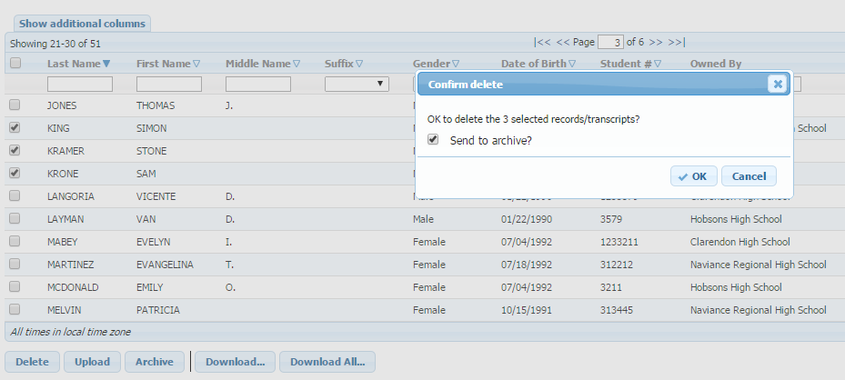
- Click the OK button to delete the selected transcripts and send them to the archive.
The Manage Uploaded Records/Transcripts page is automatically refreshed; the deleted transcripts are no longer displayed.
- Click Done to return to the home page.

Fulfilling a Transcript Order sent through OrderaTranscript.com for a Former Student
WTC users (at schools and districts) process orders from OrderaTranscript.com, an WTC site through which students (and their parents or guardians) can order transcripts.
To fulfill a transcript order sent through OrderaTranscript.com:
- Log in to the Wyoming Transcript Center (WTC).
- In the Items Requiring Attention section of the home page, click Transcript Orders. (The number of pending orders is shown next to the Transcript Orders link.)
The Transcript orders sent to (your institution) page displays all pending orders.
- Select the order you wish to process, and click the Fulfill button at the bottom of the page.
The Fulfill a transcript order request page opens on tab 1, Review Transcript Order.
Note the Enrollment column displays information about the student’s enrollment status (Currently Enrolled or Previously Enrolled). The archive features are available only when the student or guardian has selected "Previously Enrolled" on their order; otherwise, the fulfill order flow will have no archive tab matches to archive records.
- Review the order, and click Next.
The Select Record/Transcript tab displays three sub-tabs: Matching Records/Transcripts; Search for a Record/Transcript; and Search the Transcript Archive, found in the lower pane of the Select Record/Transcript tab.
- Select the record displayed in the matching records/transcripts sub-tab, or search for a record/transcript by clicking on either of the remaining sub-tabs to search records/transcripts in your institution's WTC database or search archived transcripts; or upload additional records from your local files or server to your institution's WTC database.
- Click Next.
The Confirm and Submit page, tab 3, displays.
- Review the details of this order request
Compare Requested Student and Selected Student data.
Verify the Receiving Institution's information.
Optional: Enter a message to be sent with the record/transcript.
- If there are any details you wish to check, or any steps you wish to repeat, click Previous; otherwise, click Send.
Note: The system will translate the data into the requesting institution's preferred format and send the transcript. On the next screen, the Results tab (number 4), a unique tracking number is assigned to the transcript delivery.
The Results page, tab number 4, displays.
Note that the header of this page is "Fulfillment successful", meaning that the record/transcript has been sent to WTC for processing, and a unique tracking number has been assigned.
If you wish to view the delivery details for this order, click on the tracking number in the Tracking Information section of the Results tab.
- Click Fulfill Another Order return to the Transcript orders sent to your institution page, or click Done to return to your WTC home page.

